Autonomous Coordination of
Weeding Robots
James Heselden
School of Computer Science, University of Lincoln
Brayford Pool, LN6 7TS
15591313@students.lincoln.ac.uk

Abstract— Weeding is a large industry, costing tens of billions in the global economy. The rise of robotic autonomy can assist greatly in this, allowing for a fraction of the otherwise large costs to farmers. This paper introduces an implementation of a coordinated system for tackling the issues of weeding using a robotic fleet. The approach is similar to some previous works as the system makes use of wheeled robots to move up and down crop rows in detecting and hunting weeds, however it differs from most, where the detecting and hunting of the weeds are tasks delegated to the individual robots, making them essentially unique workers attempting the global goal rather than individual and isolated systems doing their own work.
Keywords— Robotic fleet, coordination, weeding, cabbage, basil, onion, crops, image processing, task delegation
- Introduction
- Motivation
Globally weeds cause disruption to the agriculture industry, with an estimated $4 billion AUD cost to the agriculture industry in Australia alone [1].
As described by Cyrill Stachniss in a 2019 lecture, with some plant types the occurrence of only a few specific weeds, can contaminate an entire field.
For a long time, weeding has been an arduous task where workers are required to spend all day walking back and forth through the crop rows, searching for and spraying or pulling out any identified weeds [2].
With the increases in autonomy, this has become an issue which can be tackled with the aid of robotics. However, there are many challenges which must be overcome to ensure the robots are able to complete the jobs. Humans find this job easy, however for a robot to do the same thing takes a lot more work.
- Aim
The aim of this project was to find a way to tackle this challenge with the use of a robotic fleet.
- Objectives
In removing weeds there are 3 major obstacles which needed to be overcome. The first is the identification of the weeds, distinguishing them from the surrounding plants, and logging their location in 3D space. The second challenge is navigating the robot throughout the field in an organised way which can be easily adapted for any new field given. The third challenge is to implement a scalable pipeline for the coordination of the fleet of robots, and to optimise and simplify the management of the fleet.
- Related Works
- Vision Systems
A wide variety of vision systems have been developed over the years for weed identification, Machine vision systems have a long list of implementations for example, implemented by Blasco et al. [3] for their non-chemical weeding system in 2002. Their system classified pixel RGB values into categories of soil, and not soil, then weeds and cabbages. It was able to achieve a 97% success rate classifying soil, with an 84% success rate classifying the weeds, and a 99% of classifying cabbages. The vision system however was not able to reach the same levels of accuracy on the real field.
Due to the level of complexity in their system and the time available for this project, the implementation of a machine learning system is not viable. However, the use of RGB for image processing will be the first steps taken for each of the classification systems required.
- Formation Control
As described by [4], there are several different approaches to formation control and in turn coordination. Soni and Hu group the types of formation into 3 approach types.
With the Leader-Follower approach, the basis of the implementations is that there is a single leader which moves about, with the remaining robots following. There are 3 styles of implementation which can represent the leader, the first is a static leader, where a single robot is assigned the role of leader and this does not change, second is a virtual leader where the leader is not an actual robot, by a simulated ghost leader, and the third type is a dynamic leader, where the leader can switch between different robots.
Behaviour-Based approaches are mostly used for dynamic environments and work best when the world cannot be accurately modelled. As the task requires the navigation of a very well-defined region, behaviour-based approaches would not be suitable.
With the Virtual Structure approach, the aim of a system is to force a geometric shape to be consistent by the robots, for the given context, a virtual structure would be highly beneficial for managing collision avoidance when multiple robots are on the same row, however for the task assigned, it may be more complex then what is required.
- Methodology
To meet the aim of having a simple scalable system, the architecture came as an early priority. The focus on delegation of tasks was the core principle behind the architecture choice, as the robots had to be fully independent of one another, while still communicating all the required information to ensure the goals of the system were met and the weeds were sprayed in the correct spots.
The architecture breaks down as shown in Fig. 1, where the 2 robots act as a scanner and a sprayer. The Scanner runs along a path, calculated from the data stored in the configuration file. As it moves down each crop row, it scans for weeds using one of the 3 developed pipelines for the 3 crop types provided.
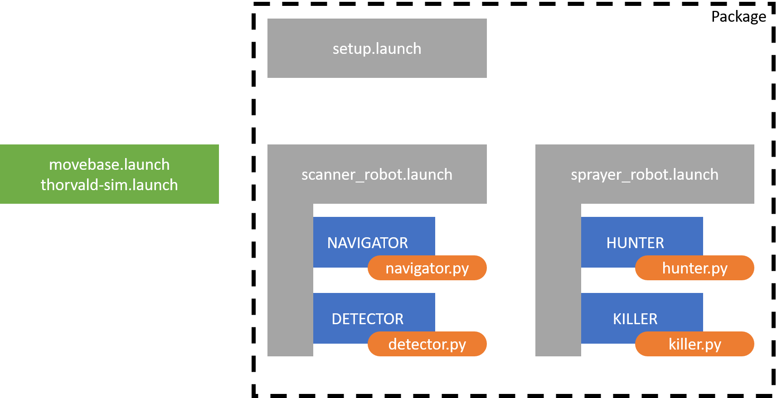
Fig. 1 Breakdown of Launch file hierarchy
At the end of the row, the scanner robot corelates all the data it collected through its pass, filters it, and sends it to the sprayer robot. Once the sprayer robot has received indication that the scanner robot is a safe distance away, it moves to each of the weeds, aligns itself and sprays. This is repeated till all weeds are covered.
- Scanner Robot
1) Weed Detection System: The process of extracting weeds from an image is a 3-process step in most cases. As there are often many different varieties of weeds in a crop row, identifying each one individually is often a very long process, and requires a large amount of processing, scanning the entire image for each type individually. Instead, it is often enough to simply detect the dirt background, which usually has a distinctive colouring to it, then to isolate the plants which are supposed to be there. Anything which does not match these two features, through a process of elimination would be a weed [5].
The basic principles of classifying different objects within any image, is to find and exploit unique features about the objects. Each of the three types of plant given in the problem domain were chosen to enable the exploitation of different features.
Basil: The first steps in image processing techniques is to investigate the colour distributions for the image under RGB and HSV. For images under the basil row, the saturation channel histogram showed 3 distinct regions, one for each the dirt, plants, and weeds (Fig. 2).
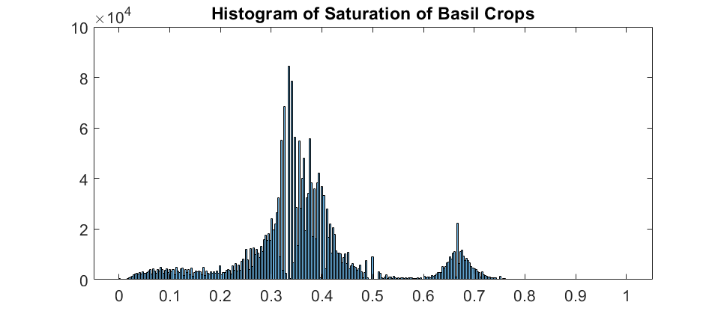
Fig. 2 Histogram of the Saturation channel of a frame of the basil row.
Specific binarizing of the image, allowed for effective classification of the dirt, basil and weeds. However an improved system was developed on top of this by taking advantage of the additional channels. Through a lot of analysis, it was found that the hue channel could be used for filtering out the dirt first, then the saturation channel showed a clearer difference between the weeds and the plants (Fig. 3).
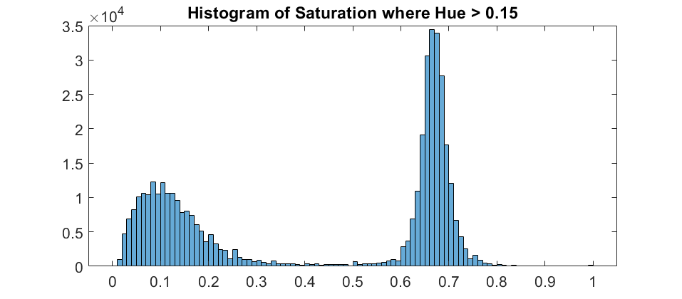
Fig. 3 Histogram of the Saturation channel of a frame of the basil row, after pre-processing to remove all pixels in the hue channel with a value greater than 0.15.
However, this was later changed to a simpler and faster system for weed extraction as it was discovered that the weeds all had a unique property where their values for saturation were all less then their value for hue. Meaning the extraction for basil weeds was done in a single line. The results of this are shown in Fig. 4.
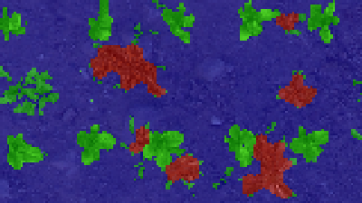
Fig. 4 Classification of basil row, low resolution used to improve speed. Note the weed on the left centre is not identified, this is caused by the border clearing system, on the following frame, the weed is labelled.
Cabbage: When the use of histogram analysis is not enough, the next systems to look at are morphological processes. For the cabbage row, the clearest difference between the weeds and the cabbage is the size. Where the cabbages are significantly larger than the weeds. Exploiting this was a simple process of, first extracting the dirt using the difference on the Hue color channel, then using a morphological opening on the cabbage and weed image, to erode away the small weeds, leaving only the cabbage. The weeds were then extracted in the same way as the basil, where the weeds were everything which wasn’t dirt or cabbage. An example of the results is found in Fig. 5.
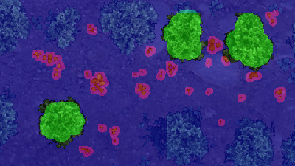
Fig. 5 Classification of cabbage row. Note the false positive around the bottom left corner of the top right cabbage.
Onion: Extracting the onion was the most difficult tasks, as the onions themselves were very thin and compared with the weeds which surround them, and nearly indistinguishable. Attempts were originally made on comparing the texture of the image using the Fourier transform, however a simpler solution was later found.
In terms of feature exploitation, the key component which distinguished the onion from the surrounding weeds was the intent from the farmer who planted them. It is a safe assumption to be made that when planted, the onion had been planted in straight lines, and that the robot would be driving parallel with these straight lines, this is backed up by the results from a paper by Cyrill [6].
Thus, an algorithm was implemented which aimed to take a highly sensitive filter of the onions, then to extrapolate the data, and build a graph of the detections across the direction of the robot (Fig. 6). This graph was then used as a layer for the probabilistic state of the locations of the onions. Some morphological operations were applied to tidy the data, and a resulting image was generated for the detection of the onion. With the dirt extracted with the same process as before, the large regions covered by weeds were identified as the result of the process of elimination (Fig. 7).
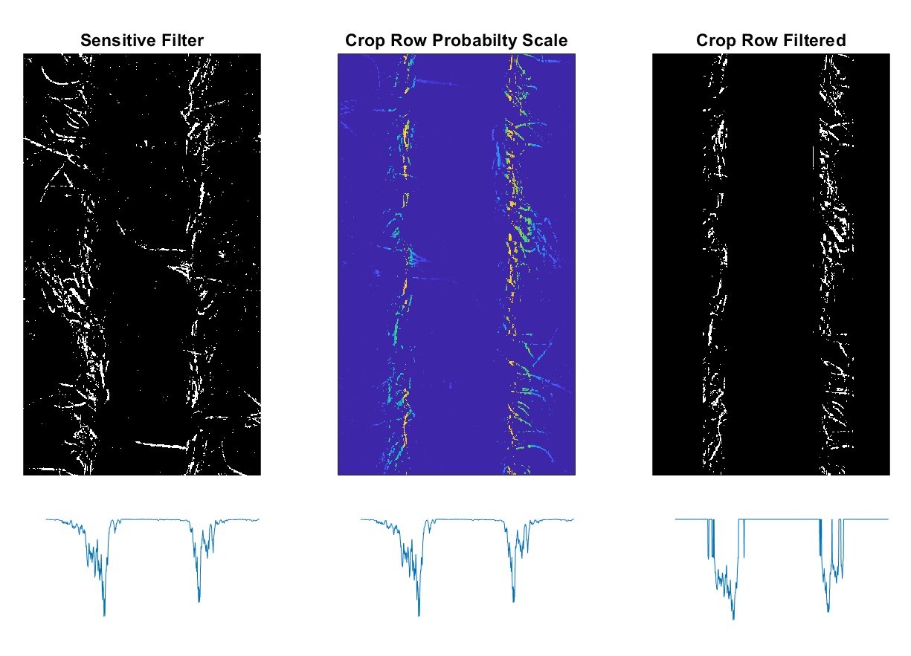
Fig. 6 From left to right, (a) Initial filtered onion crop row, (b) Scale applied for filtering regions away from crop row centres, (c) Filtered output. The graphs along the bottom of each picture represent the total number of pixels along the length of the image.
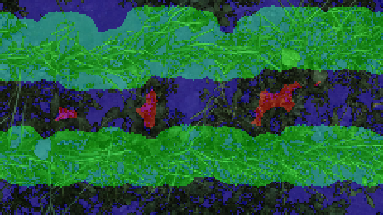
Fig. 7 Classification of onion row. Note how not all weeds are identified individually. The aim here was to identify the crops to ensure spraying was not focused on them.
1) Navigation System: Navigating robots through tight spaces comes with many issues, especially given the limitations on vision. The only sensors available are the LaserScan, Velodyne PointCloud, and the Kinect facing directly downwards, meaning observing where the crop rows are beyond the small region directly below the robot is far beyond the scope of this project.
As a result of the limited available sensors, the navigation system built for the scanner robot was quite simple, consisting entirely of the navigation stack used for movement, and a defined set of details listed within the configuration file for the package.
- Sprayer Robot
1) Navigation System: The navigation system for the sprayer robot was also designed as simple as possible, however with the limitations of the simulation robot sensors listed above, it meant there was no method of determining if the robot’s sprayer was above the weed as the position of the sprayer box on the robot is not within the region the Kinect camera is able to see.
To combat this issue, a simple algorithm was developed, where the position of each weed in the map frame would be translated by the distance between the camera and sprayer, so it would then align over the top of the weed as it was moving.
2) Sprayer System: A custom sprayer system was also developed to be deployed by the sprayer robot. This contained 2 unique components which allowed the robot to mark where it was told a weed was located, and then to drop a custom defined model within the simulation based on the details of the crop rows it was managing. For instance, in the onion rows, the weed problem is significantly worse than the cabbage row, so the size of the model dropped by the model has a varying size based on this.
- Evaluation
- Image Processing
Evaluating the performance of the weed detection is a complex task, especially given the importance of weed spraying is not explicitly defined. For this system, the highest importance was placed on not spraying any crops, as opposed to not missing any weeds. As such, all critical evaluation here has focused around analysing the number of false positives (crops labelled as weeds) in identification of weeds. True negatives (weeds labelled as crops) still have the possibility of being identified on a second pass of the system, or after a few days as their shape and size may change.
The analysis of the onion mask is a special exception and will be treated slightly differently from the others. The given scenario had very heavy weed growth, the likelihood of achieving a perfect analysis and identifying every individual weed was quite small and as such was deemed as beyond the scope of the project. Over time, as the robots make multiple passes over the rows, the number of weeds will filter down, allowing for more focused analysis to be done. Thus, the focus on the onion crop rows was to identify clusters of weeds which could be sprayed with a wider radius sprayer nozzle.
For each of the following tests the robot was shown 3m of crop rows. The system predictions and actual results were counted by hand, the results for each crop row were put into a confusion matrix.
TABLE I
Confusion Matrix for Analysis of Basil Filter
Basil | Predicted Weed
Actual |  | True | False
Actual | True | 31 | 8
Actual | False | 0 | 34

The basil filter as described before, has a heavy focus on limiting false positives (where the filter labels basil as a weed). To evaluate the system, it is important to take this into account. Given that there were 0 basil plants identified as basil, the system success is evident.
TABLE II
Confusion Matrix for Analysis of Cabbage Filter
Cabbage | Predicted Weed
Actual |  | True | False
Actual | True | 69 | 0
Actual | False | 29 | 14

The FDR of the cabbage filter is the number of cabbage plants labelled as weeds divided by the total number of cabbage plants. There is a slight issue with this calculation as the incorrect labelling of the cabbage was not the entire cabbage, but small regions around the edge of it. The FDR itself results in 29/98, a rate of nearly 30%.

TABLE III
Confusion Matrix for Analysis of Onion Filter
Onion | Predicted Weed
Actual |  | True | False
Actual | True | 16 regions | 0%
Actual | False | 0 | 100%

As the onion filter works quite differently, where the focus was on detecting the plants to avoid. Through basic inspection of the results, it is evident that there were 0 instances where plant was identified as weed, so no further calculation is necessary.
- Conclusion
- Image Processing
The weed filters have shown to be highly effective, basil and onion both have tremendous performance, however cabbage has its flaws. This however could be easily fixed by modifying the size of the morphological transformations, so the cabbages have a larger radius of coverage.
- Navigation
The implementation of the navigation system allows the controller to easily modify the pathing for the scanner robot before deployment.
- Coordination
The coordination system requires more work. At its current state, the only level of coordination is communications system and the requirement of the sprayer robot to stay at least 2 crop-rows away from the scanner robot. An advanced coordination system could be implemented which makes use of topological maps to manage the robots’ locations, however due to time constraints this was not a possibility for this project.
- Scalability
Due to the design of the core components and the method of task distribution, the system design allows for a simple scalable solution, which is able to handle as many robots for scanners and sprayers as available, and is able to combine the job roles easily so the sprayer and robot tasks could be handled all by 1 robot. The most important part of the coordination is to design the system to be able to handle as many robots as available. This system design did just that.
References
[1] Department of Environment and Conservation, “Impact of weeds on threatened biodiversity in New South Wales”, Jan. 3007. [Online] Available: https://webarchive.nla.gov.au/awa/20070130043825/http://pandora.nla.gov.au/pan/64168/20070119-0000/www.weeds.crc.org.au/documents/tech_series_11.pdf
[2] K. Jabran and S. Bhagirath, Non-Chemical Weed Control, 1st ed., London UK: Academic Press, 2018.
[3] J. Blasco, N. Aleixos, J. M. Roger, G. Rabatel, and E. Moltó. “AE—Automation and emerging technologies: Robotic weed control using machine vision,” Biosystems Eng., vol.83 no.2, pp.149-157. Jul. 2002.
[4] A. Soni and H. Hu, “Formation control for a fleet of autonomous ground vehicles: A survey,” Robotics, vol.7 no.4, pp.67. Nov. 2018.
[5] C. Fox, Interviewee, and Z. Tong, Interviewer, Daily Planet, [Television broadcast], Canada: Discovery, Apr. 6, 2016.
[6] P. Lottes, J. Behley, N. Chebrolu, A. Milioto, and C. Stachniss, “Robust joint stem detection and crop‐weed classification using image sequences for plant‐specific treatment in precision farming”. Journal of Field Robotics. 2019.

